**Lab 1**

A.

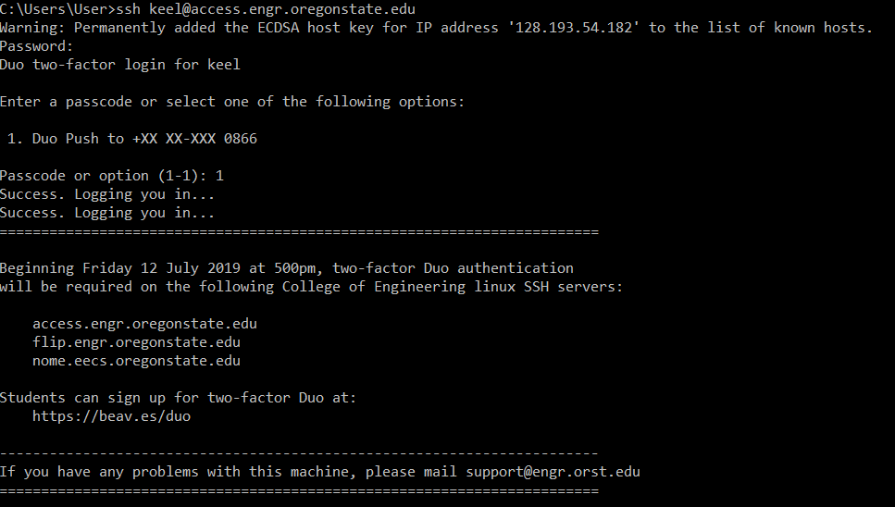

B.

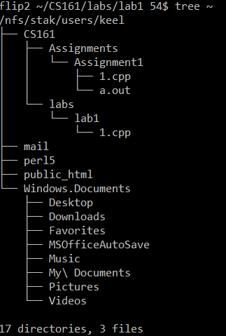

C.

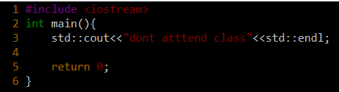

D.

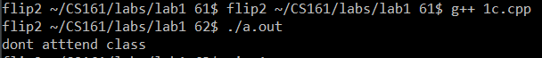

E.

Ex1:

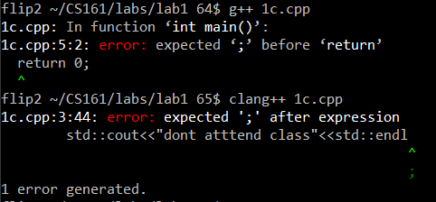

clang is more exact and it also shows you what to do.

EX2:

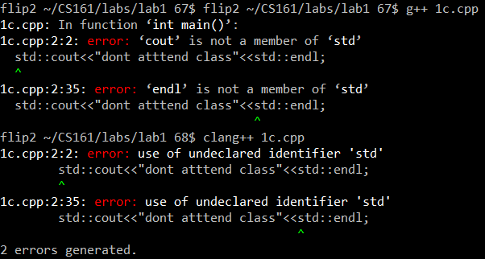

Again, clang is more specific and it tells you that std isn’t declared rather than just generally that cout isn’t a member of std which technically means that you should declare it to use it.

EX3:



Both indicated that there were no issue and the file was compiled to a.out.

EX4:

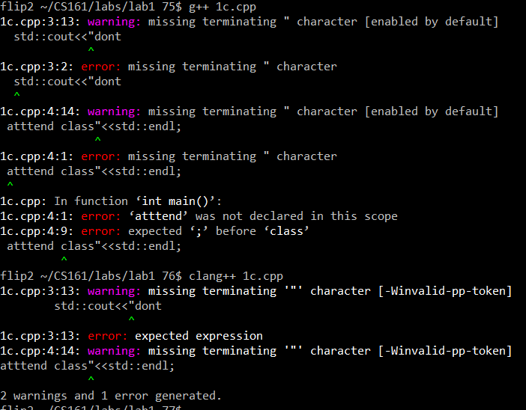

g++ tries to identify a terminating symbol at the end of every line, however clang doesn’t and only shows 2 warnings and 1 error where g++ showed the error where a “;” is missing from a line.

Challenge 1 & 2

Code:

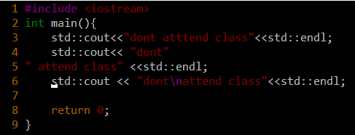

Output:

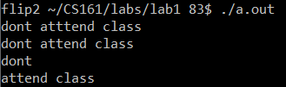

F.

1. How many inputs will your program request from the user?

There will be 5 user inputs namely: arrayIndexRange, timeToSolveBugs, ageOfHumanity, numberOfRevolutions, spinMins.

2. How will you decide which data types to use for each variable?

It will be depending on what it could possibly take as a data to not make the program run with logical or run-time errors where it could disrupt the flow with a decimal and so on…

3. Will you predict good fortunes, bad fortunes, or a mixture?

It will be a mixture of one bad one good and one that is both good and bad.